**Day 4**

**NAME :K.Nithin Sai**

**REG NO :192124024**

**COURSE :SOFTWARE ENGINEERING**

**CODE :CSA1001**

**FACULTY :DR.MARY VALANTINA.G**

**DATE :29/09/22**

LAB MANUAL 18 to 25

EXPERIMENT :18

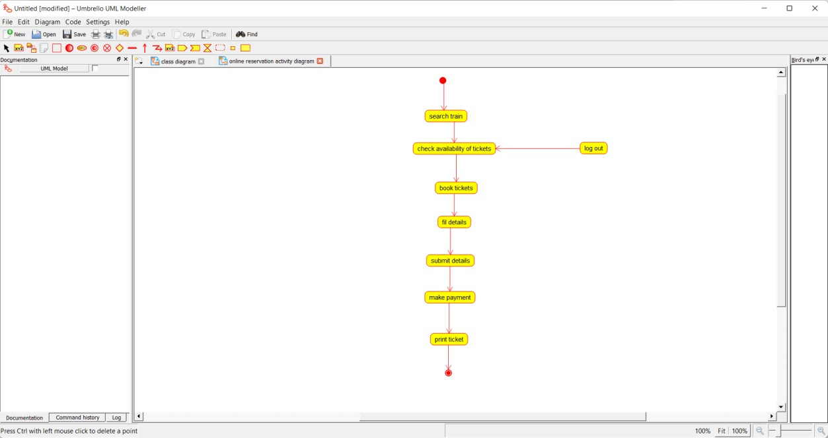

EXPERIMENT :19

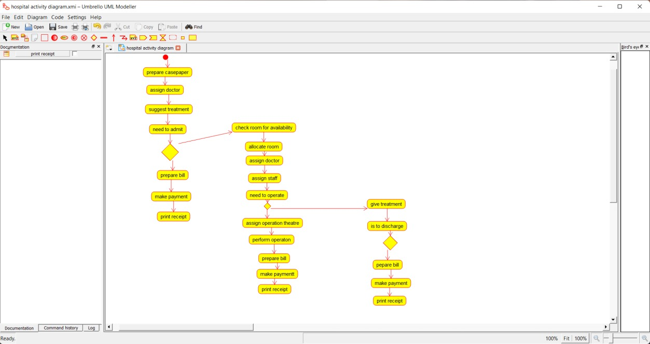

EXPERIMENT :20

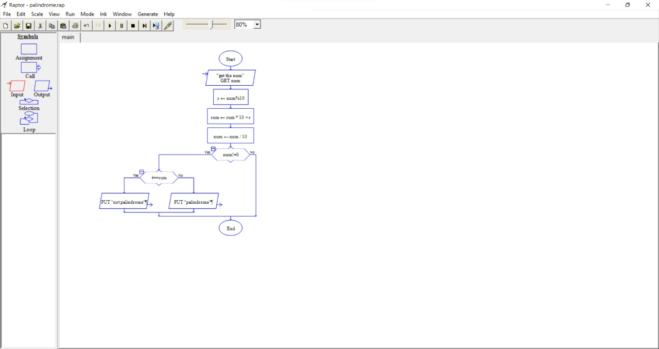

EXPERIMENT :21

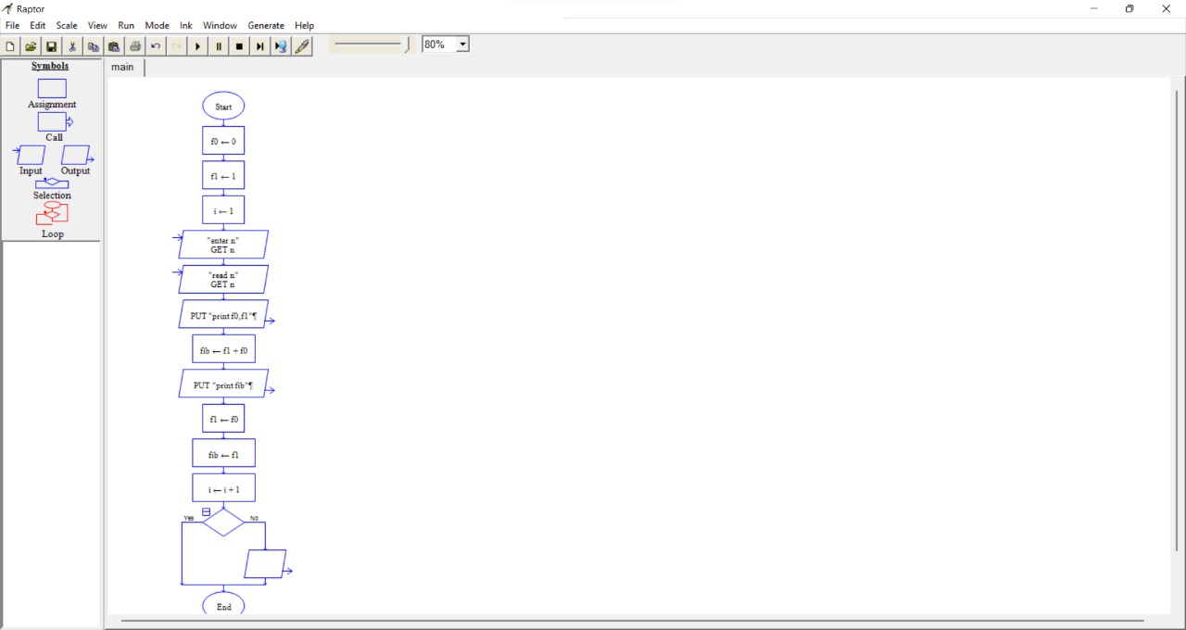

EXPERIMENT :22

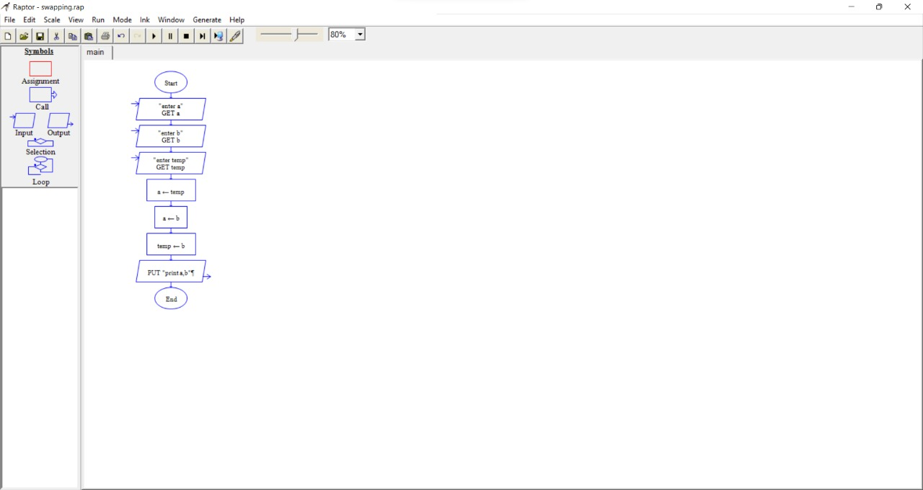

EXPERIMENT :23

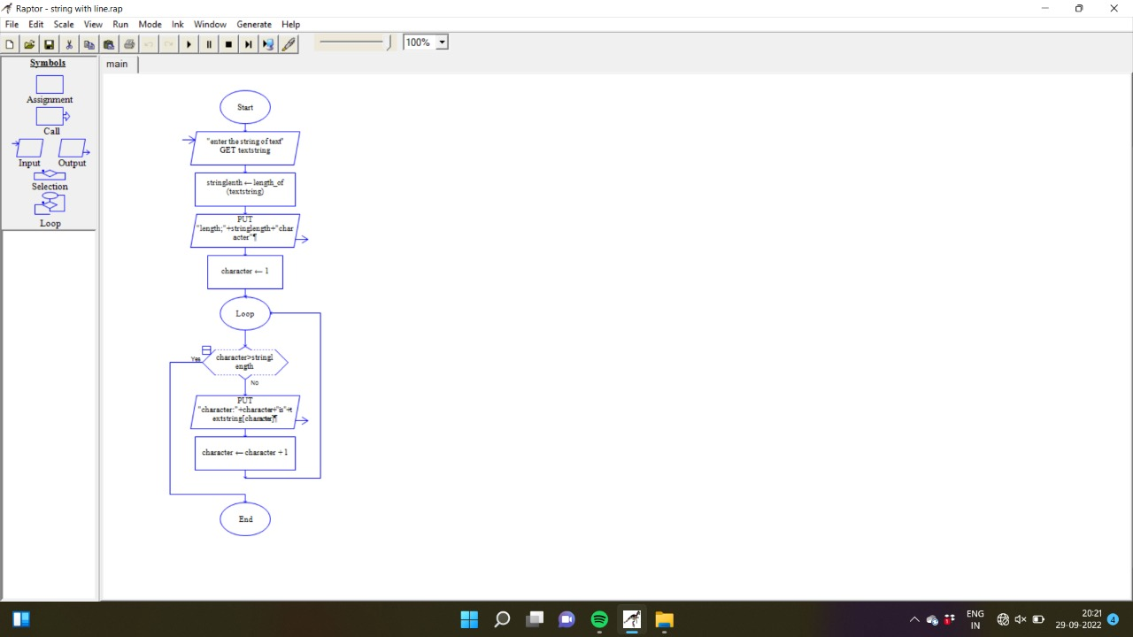

EXPERIMENT :24

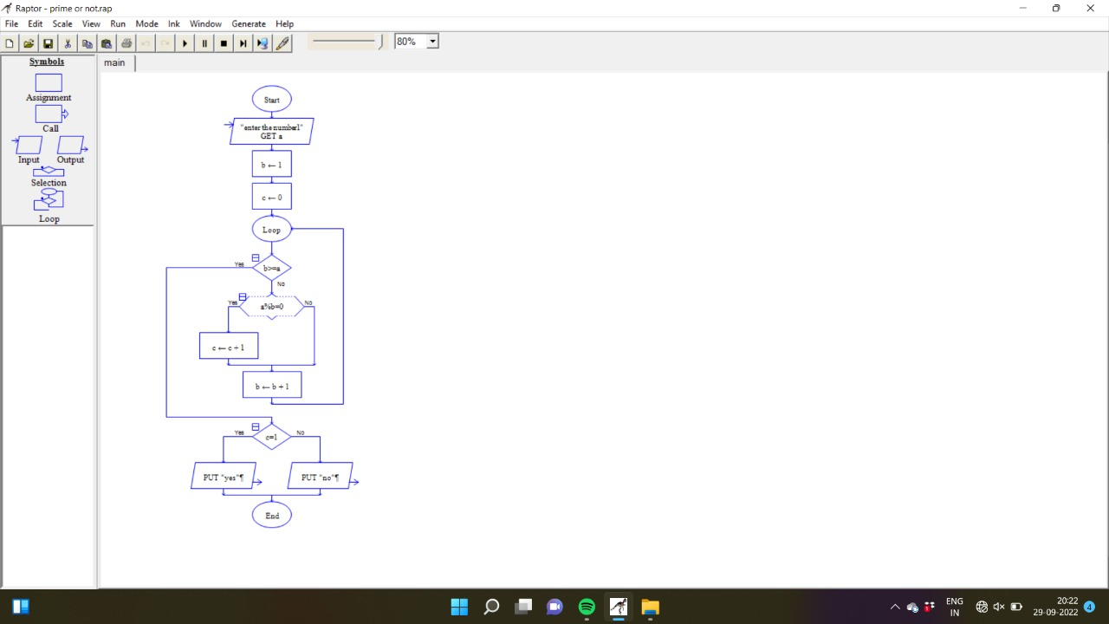

EXPERIMENT :25

